**Running a static web app on AWS.**

Step 1: For this lab you will need the following software

* AWS Free Tier account

Step 2: Create an S3 bucket on AWS. Change the permissions and the policy to make the bucket accessible.

.

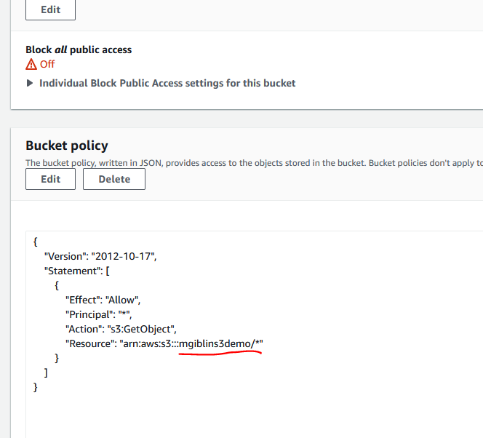

Step 3: Upload the files provided to the bucket

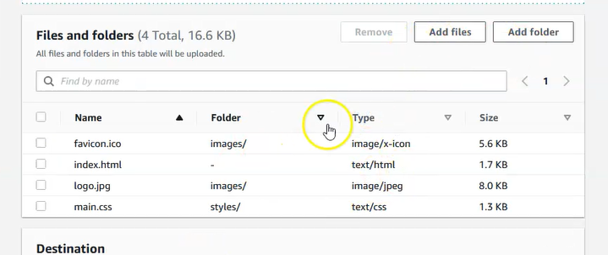

Step 4: Check that the page is accessible on a browser from your local machine.

